Final Project Report

Smart Water Management System: IoT-Based Tank Monitoring and Pump Automation



Project Supervisor
Dr. Israr Ullah

Submitted By

Usama Ahmad
F2302894E5 (BC200406015)

Software Projects & Research Section,
Department of Computer Sciences,
Virtual University of Pakistan


CERTIFICATE

This is to certify that Usama Ahmad (F2302894E5 (BC200406015) ) have worked on and completed their IoT-Based Project at Software & Research Projects Section, Department of Computer Sciences, Virtual University of Pakistan in partial fulfillment of the requirement for the degree of BS in Computer Sciences under my guidance and supervision.

In our opinion, it is satisfactory and up to the mark and therefore fulfills the requirements of BS in Computer Sciences.

Supervisor / Internal Examiner

Supervisor Dr. Israr Ullah,
Software Projects & Research Section,
Department of Computer Sciences
Virtual University of Pakistan

___________________
(Signature)

External Examiner/Subject Specialist
<<External Supervisor Name>>

___________________
(Signature)

Accepted By:

_____________
(For office use)

EXORDIUM

In the name of Allah, the Compassionate, the Merciful.

Praise be to Allah, Lord of Creation,
The Compassionate, the Merciful,
King of Judgment-day!

You alone we worship, and to You alone we pray for help,
Guide us to the straight path

The path of those who You have favored,

Not of those who have incurred Your wrath,
Nor of those who have gone astray.

DEDICATION
This project is dedicated to furthering the development of innovative solutions for sustainable water management. The exploration of Internet of Things (IoT) technology in this smart water management system holds promise for optimizing water usage and promoting responsible resource conservation.

ACKNOWLEDGMENT
The successful completion of this smart water management system based on IoT technology would not have been possible without the invaluable support and contributions of several individuals and entities. We would like to express our sincere gratitude to:

Supervisor: Dr. Israr Ullah for their guidance, mentorship, and expertise throughout the project. Their knowledge and advice were instrumental in shaping the direction and ensuring the quality of this work.
Family and Friends: I am grateful to my family and friends for their unwavering support and encouragement during this project.
Online Resources:I acknowledge the wealth of information available online, particularly from reputable sources such as [List specific websites or resources that were helpful, e.g., academic journals, technical documentation from sensor/component manufacturers]. These resources provided a strong foundation for understanding and implementing the technical aspects of the project.

PREFACE
Smart Water Management System using IoT
Water is a vital resource for all life on Earth, and its sustainable management is becoming increasingly crucial. Traditional water management systems often face challenges such as inefficient use, leaks, and difficulty in monitoring consumption. This final report presents the design, development, and implementation of a smart water management system utilizing Internet of Things (IoT) technology.
Report Structure:
This report is structured to provide a comprehensive understanding of the developed smart water management system. Here's an overview of the key chapters:
- Chapter 1: Gathering & Analyzing Information: This chapter establishes the context by introducing the project, its purpose, and scope. It defines relevant terms and outlines the project requirements, both functional (desired functionalities) and non-functional (performance and usability aspects). The chapter dives into use cases and usage scenarios, detailing real-world situations where the system can be applied, and provides a visual representation using use case diagrams. Finally, it describes the chosen development methodology, providing justification for the selection and including a work plan (Gantt chart) and project schedule for reference.
- Chapter 2: Designing the Project: This chapter delves into the system design. It introduces the design goals and scope, then presents an architectural diagram showcasing the overall system structure. Dynamic models like sequence diagrams are included to illustrate interactions between system components. For clarity, a state machine diagram might be included to demonstrate the system's behavior under different conditions. The chapter also details the circuit design diagram, providing a blueprint for hardware connections. Finally, it explains the design considerations for the Graphical User Interface (GUI), the user interaction point with the system.
- Chapter 3: Development delves into the project's construction, focusing on the detailed development plan (architectural diagram). This section showcases how the conceptual design from Chapter 2 translates into a concrete implementation road map.

TABLE OF CONTENTS

CHAPTER NO. 1
gathering & Analyzing inf 9

1.1 Introduction

1.2 purpose

1.3 scope

1.4 definitions, acronyms and abbreviations

1.5 Project requirements

1.5.1 Functional Requirements

1.5.2 Non-Functional Requirements

1.6 use cases and usage scenarios

1.6.1 Use Case Diagrams

1.6.2 Usage Scenarios

1.7 Development Methodology

1.7.1 Chosen Methodology

1.7.2 Reasons for Chosen Methodology
1.7.3 Work Plan (Gantt Chart)
1.7.4 Project Schedule (Submission Calendar)

CHAPTER NO. 2
designing the project 15

2.1 Introduction

2.2 purpose

2.3 scope

2.4 definitions, acronyms and abbreviations

2.5 Architectural Representation (Architecture Diagram)

2.6 Dynamic Model: Sequence Diagrams

2.7 System State Machine Diagram

2.8 Circuit Design Diagram

2.9 Graphical User Interfaces

Chapter no.3
Development Plan 22
3.1 Development plan (Architecture Diagram)

3.2 Project Overview
3.3 Components:
3.4 Development Phases

CHAPTER 1
Gathering & Analyzing Info

  - Introduction

The Smart Water Management System (SWMS) is an innovative and user-friendly solution designed to optimize water usage and provide peace of mind for homeowners. This system utilizes a network of sensors and a mobile app to monitor water levels, automate pump operation, and eliminate the need for manual intervention.

1.2 purpose
The purpose of this project is to develop a smart IoT-based solution for automating water tank monitoring, filling, and pump operation. This will help to address common household challenges such as water overflow, pump damage, and manual labour.

1.3 scope
The scope of this project is to develop an IoT-based solution for automating the water tank monitoring, filling, and pump operation process. The system will consist of two main components: a hardware component and a IoT Project component.
The hardware component will include an ESP32 development board, an ultrasonic sensor, a water flow sensor, a relay module, and a 5V water pump. The IoT Project component will include a Blynk mobile app and an ESP32 Micro-Controller.

1.4 definitions, acronyms and abbreviations

- SRS: Software Requirement Specification SRS Document: #
- IoT: Internet of Things IoT Project component: #
- ESP32: Expressed as ESP32 development board throughout the document ESP32 Development Board: #
- Blynk: Expressed as Blynk mobile app throughout the document Companion Mobile App: #
- GUI: Graphical User Interface Design phase: #

1.5 Project requirements

1.5.1 Functional Requirements
- The automated system will have the following functional requirements:
- Continuously monitor the water level in the roof tank using an ultrasonic sensor.
- Automatically start the water pump when the water level falls below a predefined threshold in the roof tank.
- Monitor water flow in the pipe using a water flow sensor and stop the pump when there is no water flow (indicating that the ground tank is empty).
- Automatically stop the water pump when the water level rises above a predefined threshold to prevent water overflow.
- Companion Mobile App
- The companion mobile app will have the following functional requirements:
- Display the current water level in the roof tank.
- Allow users to manually turn on/off the water pump from the app.

1.5.2 Non-Functional Requirements
The system will have the following non-functional requirements:
- Reliability: The system will be reliable and operate without failures for extended periods of time.
- Accuracy: The water level measurements will be accurate.
- Responsiveness: The system will respond to changes in water level and pump status quickly.
- User-friendliness: The mobile app will be easy to use and navigate.

1.6 use cases and usage scenarios

1.6.1 Use Case Diagrams

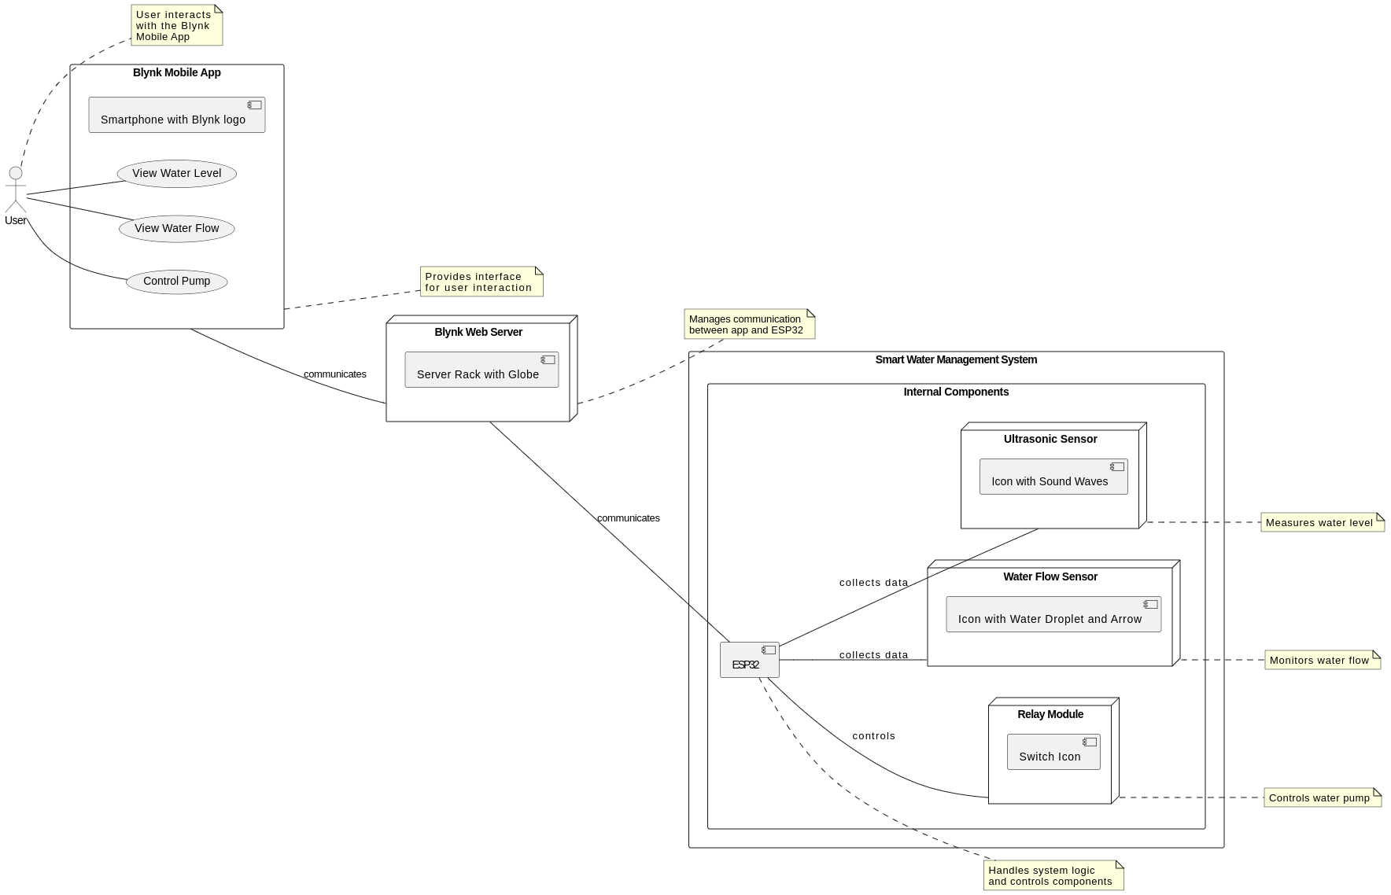

1.6.2 Usage Scenarios
Use Case Title | Use Case Id | Actions | Description | Alternative Paths | Pre-Conditions | Post-Conditions | Author | Exceptions
Monitor water level | UC-1 | 1. The ultrasonic sensor measures the water level in the roof tank. | 2. The ESP32-Micro-Controler reads the sensor data and sends it to the Blynk mobile app. | N/A | The water level is displayed on the mobile app. | The water level is displayed on the mobile app. | BC200406015 | N/A
Start water pump | UC-2 | 1. The water level falls below a predefined threshold. | 2. The ESP32-Micro-Controler sends a signal to the relay module to turn on the water pump. | N/A | The water pump turns on and starts filling the ground tank. | The ground tank is filled with water. | BC200406015 | N/A
Stop water pump (no flow) | UC-3 | 1. The water flow sensor detects no water flow in the pipe. | 2. The ESP32-Micro-Controler sends a signal to the relay module to turn off the water pump. | N/A | The water pump turns off. | The water pump is off. | BC200406015 | N/A
Stop water pump (overflow) | UC-4 | 1. The water level rises above a predefined threshold. | 2. The ESP32-Micro-Controler sends a signal to the relay module to turn off the water pump. | N/A | The water pump turns off. | The water tank is not overflowing. | BC200406015 | N/A
Turn on water pump manually | UC-5 | 1. The user presses the "Turn on pump" button on the mobile app. | 2. The Blynk mobile app sends a signal to the ESP32-Micro-Controler. | 3. The ESP32-Micro-Controler sends a signal to the relay module to turn on the water pump. | N/A | The water pump turns on. | BC200406015 | N/A
Turn off water pump manually | UC-6 | 1. The user presses the "Turn off pump" button on the mobile app. | 2. The Blynk mobile app sends a signal to the ESP32- Micro-Controller. | 3. The ESP32-Micro-Controler sends a signal to the relay module to turn off the water pump. | N/A | The water pump turns off. | BC200406015 | N/A

1.7 Development Methodology

1.7.1 Chosen Methodology
As per requirements we will adopt the methodology named. “VU process model”.
The description which is given below.

1.7.2 Reasons for Chosen Methodology
The VU Methodology is well-suited for this smart water management project due to its strengths:
- Requirement Focus: Initial phases prioritize understanding stakeholder needs, crucial for effective water management solutions.
- Iterative Development: The VU process allows for continuous improvement and adaptation as the project progresses.
- Phased Project Management: The structured breakdown into phases ensures efficient project execution and adherence to timelines.
This methodology aligns well with the project's goals by:
- Ensuring Clear Requirements: A comprehensive understanding of needs drives the development of a system that effectively addresses water management challenges.
- Enabling Adaptability: The iterative approach allows for continuous improvement and integration of new technologies.
- Promoting Efficiency: The phased structure facilitates efficient resource allocation and project management.
The VU Methodology provides a strong foundation for developing a successful smart water management system.

1.7.3 Work Plan (Gantt Chart)

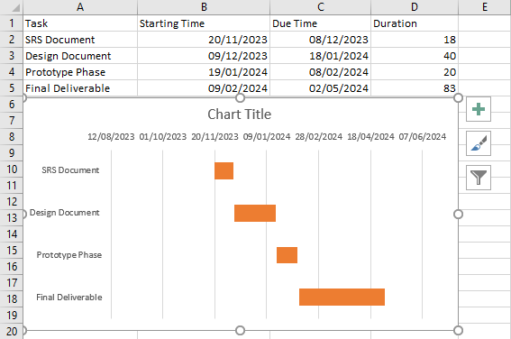
1.7.4 Project Schedule (Submission Calendar)

Task | Starting Time | Due Time | Duration
SRS Document | 20/11/2023 | 08/12/2023 | 18 days
Design Document | 09/12/2023 | 18/01/2024 | 40 days
Prototype Phase | 19/01/2024 | 08/02/2024 | 20 days
Final Deliverable | 09/02/2024 | 02/05/2024 | 83 days

CHAPTER 2
Designing the Project

2.1 Introduction

The Smart Water Management System (SWMS) is an innovative and user-friendly solution designed to optimize water usage and provide peace of mind for homeowners. This system utilizes a network of sensors and a mobile app to monitor water levels, automate pump operation, and eliminate the need for manual intervention.

2.2 purpose
The purpose of this project is to develop a smart IoT-based solution for automating water tank monitoring, filling, and pump operation. This will help to address common household challenges such as water overflow, pump damage, and manual labour.

2.3 scope
The scope of this project is to develop an IoT-based solution for automating the water tank monitoring, filling, and pump operation process. The system will consist of two main components: a hardware component and a IoT Project component.
The hardware component will include an ESP32 development board, an ultrasonic sensor, a water flow sensor, a relay module, and a 5V water pump. The IoT Project component will include a Blynk mobile app and an ESP32 Micro-Controller.

2.4 definitions, acronyms and abbreviations

- SRS: Software Requirement Specification SRS Document: #
- IoT: Internet of Things IoT Project component: #
- ESP32: Expressed as ESP32 development board throughout the document ESP32 Development Board: #
- Blynk: Expressed as Blynk mobile app throughout the document Companion Mobile App: #
- GUI: Graphical User Interface Design phase: #

2.5 Architectural Representation (Architecture Diagram)

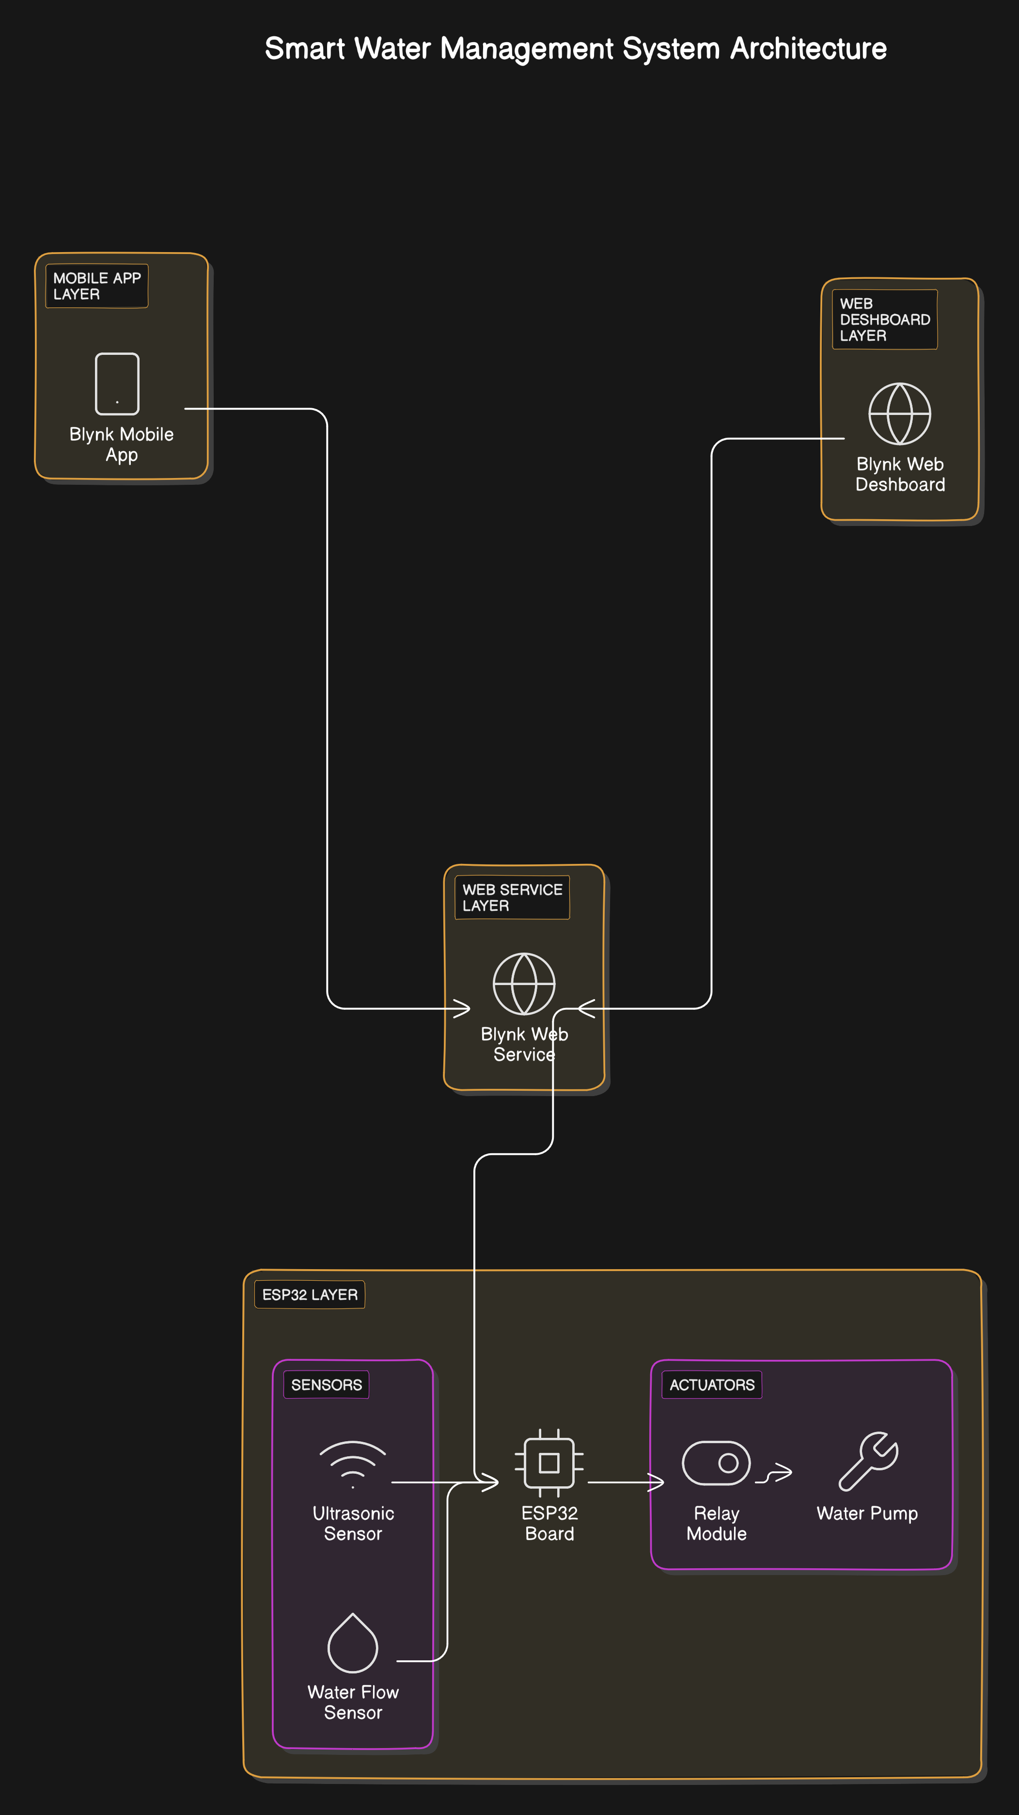

2.6 Dynamic Model: Sequence Diagrams

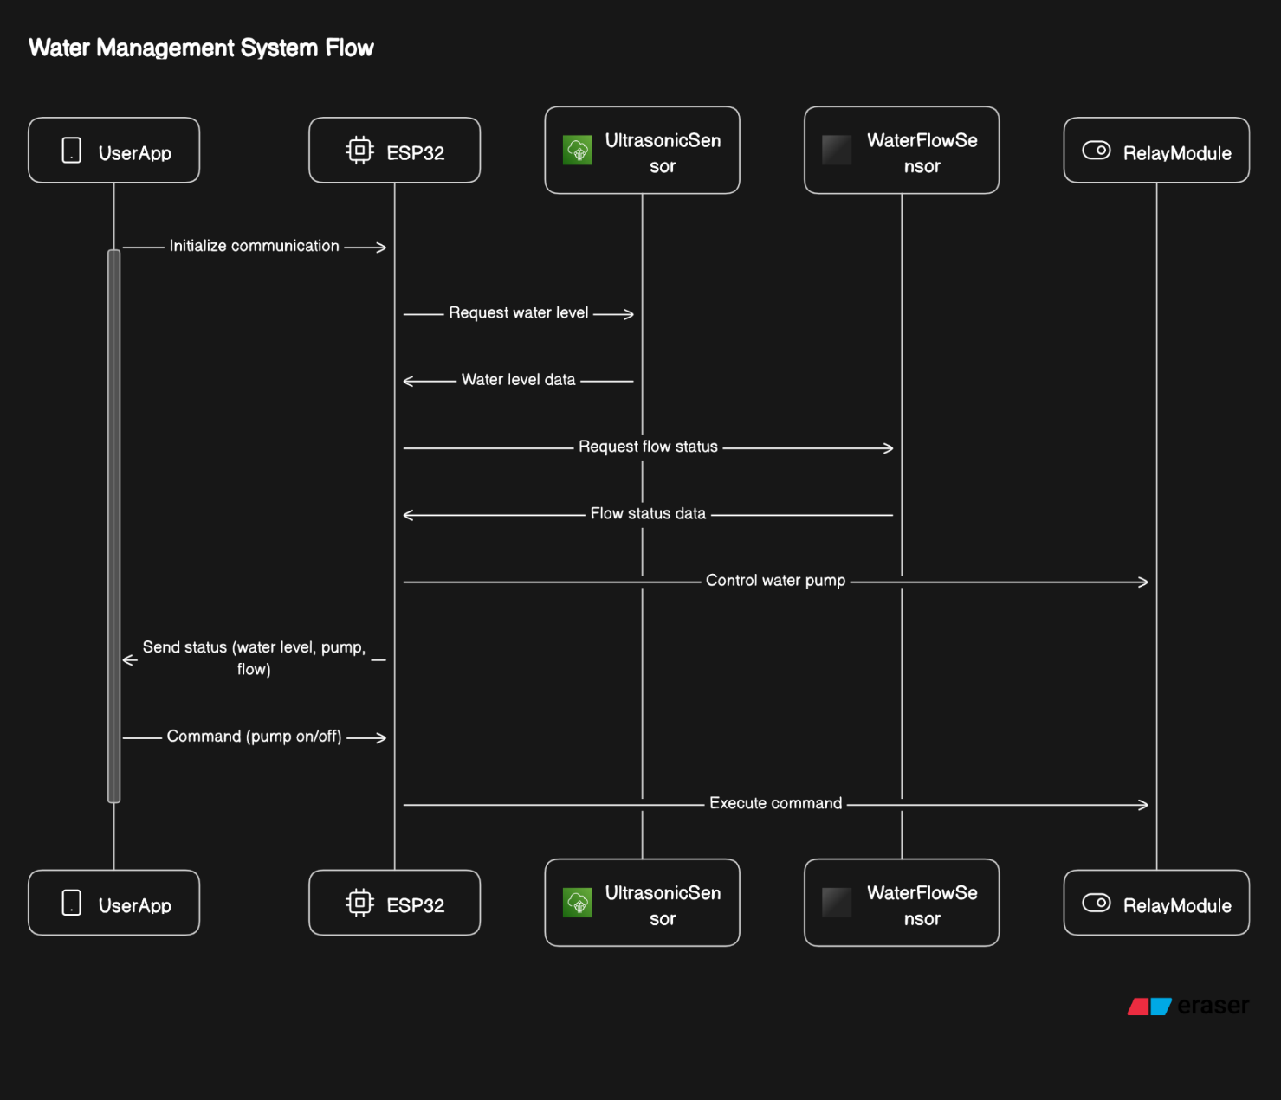

2.7 System State Machine Diagram
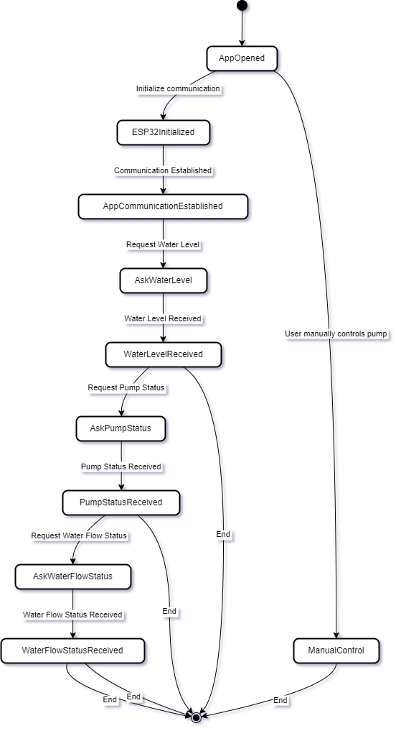

2.8.Circuit Design Diagram
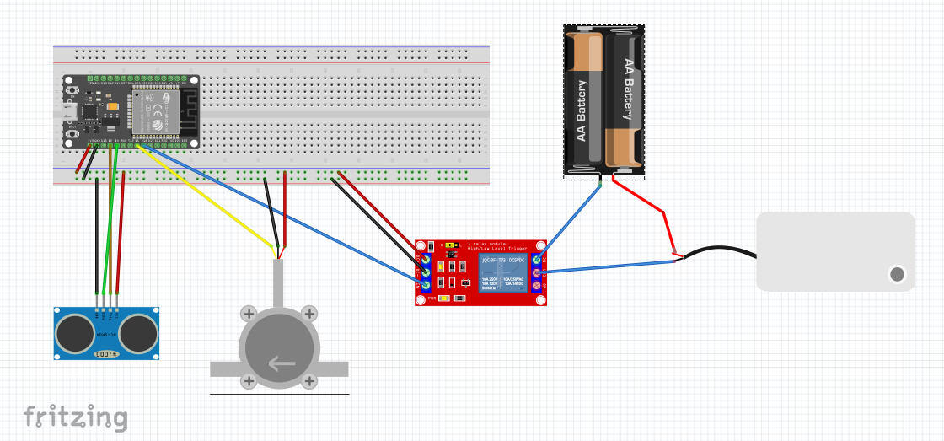

2.9 Graphical User Interfaces
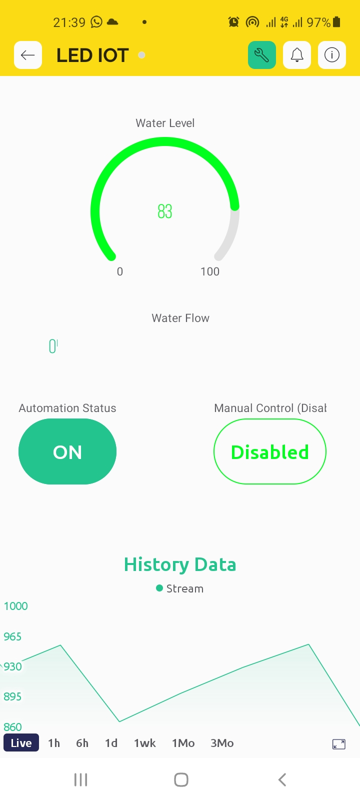

CHAPTER 3
Development

3.1 Development plan (Architecture Diagram)

3.2 Project Overview:
This project aims to develop a smart water management system utilizing the Internet of Things (IoT) to automate water flow and monitor water levels. The system will employ an ESP32 microcontroller, ultrasonic and water flow sensors, a relay module, and a Blynk platform for remote control and data visualization.
3.3 Components:
- ESP32 Microcontroller: The core of the system, responsible for processing sensor data, controlling the relay module, and communicating with Blynk.
- Ultrasonic Sensor: Measures the distance to the water surface in a tank or reservoir.
- Water Flow Sensor: Detects the rate of water flow through a pipe.
- Relay Module: Controls the power supply to the water pump, enabling automated or manual activation.
- Blynk Platform: Provides a user interface for remote monitoring (water level and flow data) and control (manual pump activation).
3.4 Development Phases:
Phase 1: Hardware Design and Assembly (1 week)
- Schematic Design: Create a circuit diagram illustrating the connections between ESP32, sensors, relay module, and power supply. You can use online tools or software like Fritzing to create this diagram.
- Component Sourcing: Procure all necessary hardware components (ESP32 board, sensors, relay module, power supply, connecting wires).
- Breadboard Prototyping: Build a basic test circuit on a breadboard to verify sensor readings and relay module functionality. This allows for quick testing and troubleshooting before soldering components onto a PCB.
- PCB Design (Optional): For a more permanent solution, design a Printed Circuit Board (PCB) for the system layout. This improves durability and organization.
Phase 2: Software Development (2 weeks)
- ESP32 Programming: Develop code for the ESP32 to:
  - Read data from the ultrasonic and water flow sensors.
  - Calculate water level based on ultrasonic sensor readings (distance to water surface).
  - Control the relay module to turn the water pump on/off based on programmed logic or user commands.
  - Establish communication with the Blynk platform for data transmission and control.
- Blynk App Development: Design the Blynk mobile app interface to:
  - Display real-time water level and flow data.
  - Provide buttons for manual control of the water pump.
  - Allow for setting thresholds to trigger automatic pump activation/deactivation based on water level readings.
  - Consider incorporating visual elements like gauges or graphs to represent water level and flow data.
- Blynk Web Dashboard (Optional): Develop a basic web dashboard using Blynk web server for broader access on a computer or tablet.
Phase 3: System Testing and Integration (1 week)
- Unit Testing: Individually test the functionality of each hardware component (ESP32 code, sensors, relay module).
- Integration Testing: Verify the combined operation of all components, including data transfer and control between ESP32 and Blynk.
- Field Testing (Optional): If feasible, conduct tests in a real-world environment (e.g., water tank) to assess system performance and adjust parameters as needed. This helps identify any issues that might arise in a practical setting.
Phase 4: Documentation and Reporting (1 week)
- Project Documentation: Create comprehensive documentation outlining the system design, hardware components, software development process, and user instructions. Include clear instructions on how to assemble the hardware, install the Blynk app, and use the system.
- Final Report: Compile a detailed report summarizing the entire project, including objectives, development phases, technical specifications, results (data collected during testing), and conclusions. Discuss the project's effectiveness, challenges encountered, and potential improvements.
- Presentation (Optional): Prepare a presentation to showcase the system's features and functionalities if required by the final deliverable requirements.

REFERENCES

Arduino Documentation for programming
https://docs.arduino.cc/programming/
Blynk Documentation
https://docs.blynk.io/en
Arduino IDE
https://www.arduino.cc/en/software
Installing ESP32 Add-on in Arduino IDE
https://randomnerdtutorials.com/installing-the-esp32-board-in-arduino-ide-windows-instructions/
Sit to buy component
https://digilog.pk/products/esp32-nodemcu

APPENDIX

System Components:
  - ESP32 Microcontroller: The central processing unit of the system, responsible for gathering data from sensors, processing it, and controlling the relay module.
  - Ultrasonic Sensor: Used for measuring the water level in the tank or reservoir.
  - Water Flow Sensor: Monitors the flow rate of water through pipes or channels.
  - Relay Module: Controls the on/off state of the water pump based on commands from the ESP32.
  - Blynk Mobile App: Allows users to remotely monitor water levels, control the pump manually, and set automation thresholds.
  - Blynk Web Dashboard: Provides a visual interface for users to monitor system status and configure settings from a web browser.
Functionality:
  - Continuous Monitoring: The system continuously monitors water levels using the ultrasonic sensor and displays real-time data on the Blynk Mobile App and Web Dashboard.
  - Automation: Users can set thresholds for automatic pump control. When the water level falls below a certain threshold, the system automatically activates the pump until the level rises above another threshold or other conditions are met.
  - Manual Control: Users can manually turn the water pump on or off using the Blynk Mobile App or Web Dashboard.
  - Data Visualization: The Blynk interface provides graphical representations of water levels, flow rates, and system status for easy interpretation.
  - Remote Access: Users can access and control the system from anywhere with an internet connection, enhancing convenience and flexibility.
Communication Protocol:
  - The ESP32 communicates with the Blynk cloud service using the Blynk protocol, allowing bidirectional data exchange between the hardware and the mobile app/web dashboard.
  - Sensor data is transmitted from the ESP32 to the Blynk server, which updates the user interface in real-time.
  - Control commands from the user interface are sent to the ESP32 through the Blynk server, enabling remote control of the system.
Security Measures:
  - The Blynk platform employs secure communication protocols, such as SSL/TLS encryption, to protect data transmitted between the user's device and the server.
  - User authentication mechanisms, such as API tokens or login credentials, are required to access the system, ensuring only authorized users can control and monitor the water management system.
Scalability and Customization:
  - The system architecture allows for scalability by adding additional sensors or actuators as needed to accommodate different water management scenarios.
  - Users can customize automation thresholds and system settings through the Blynk interface to adapt the system to specific requirements or preferences.

